1. **INTRODUCTION**
   1. *overview*
      * *Description of the project*

Project Description:

* 1. Keerthi Sweets a Manufacturer and Trader of Sweets, relies on Zoho Books to manage their inventory, handle purchase orders, and generate invoices for their customers. They can track stock levels, manage supplier payments, and generate financial reports. Zoho Books helps them streamline their wholesale operations and optimize inventory management. Keerthi Sweets is a renowned manufacturer and trader of delectable sweets, catering to both wholesale and retail customers. With a rich heritage spanning several decades, Keerthi Sweets has earned a reputation for its commitment to quality, authenticity, and customer satisfaction. Specializing in a wide variety of traditional and innovative sweets, they combine traditional recipes with modern techniques to create flavors that tantalize taste buds. Keerthi Sweets is a Private Limited company also registered under GST in Tamil Nadu. Keerthi sweets is a Manufacturer and trader of various sweets in wholesale and retail, it has a wide range of customers (B2B & B2C) all over the state and it procures raw material from various suppliers in the state. It operates at a Gross Profit margin of 50%
  2. **PURPOSE**

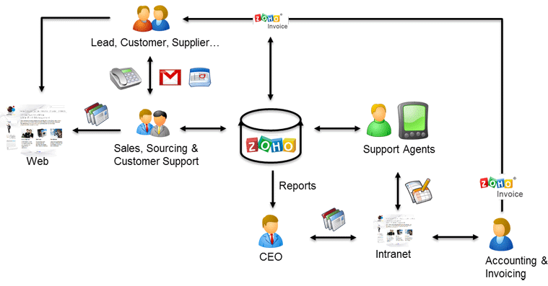

As a Center of Excellence, HealthHub Clinics offers multi-disciplinary resources and smart healthcare solutions, supported by a holistic and compassionate approach, understanding and quality care designed around your health.

1. **Problem definition & design Thinking**
   1. *Empathy map*

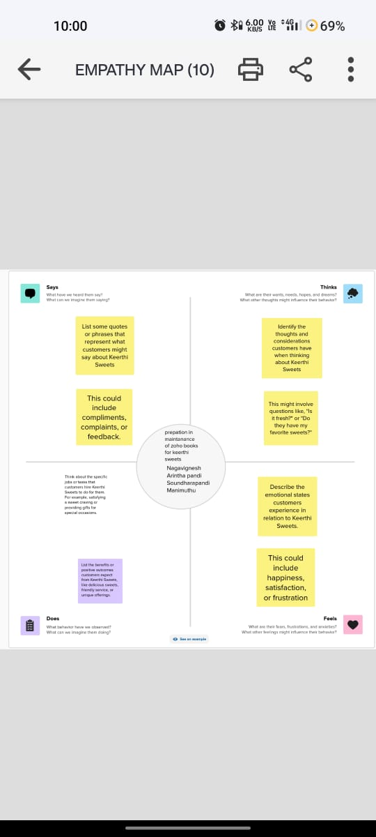

* 1. *Ideation & Brainstorming map*

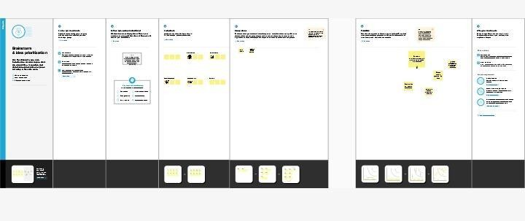

1. **Result Profit&loss**

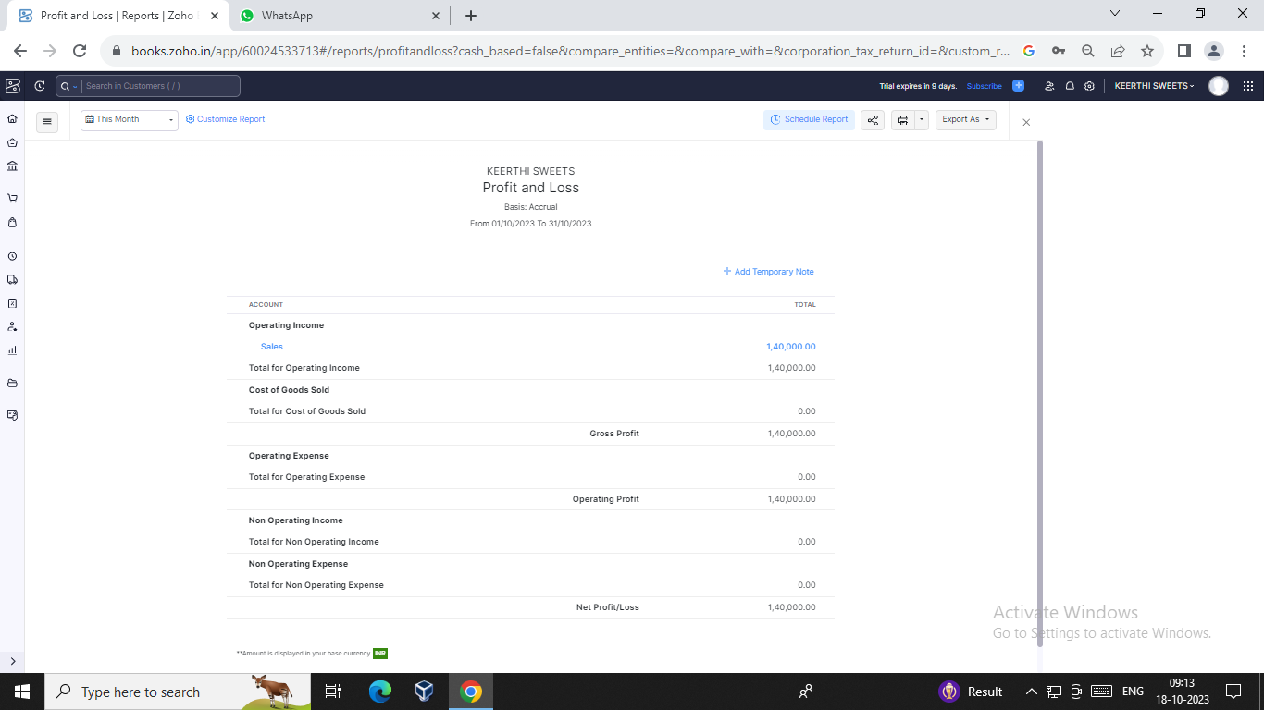

Balance sheet:

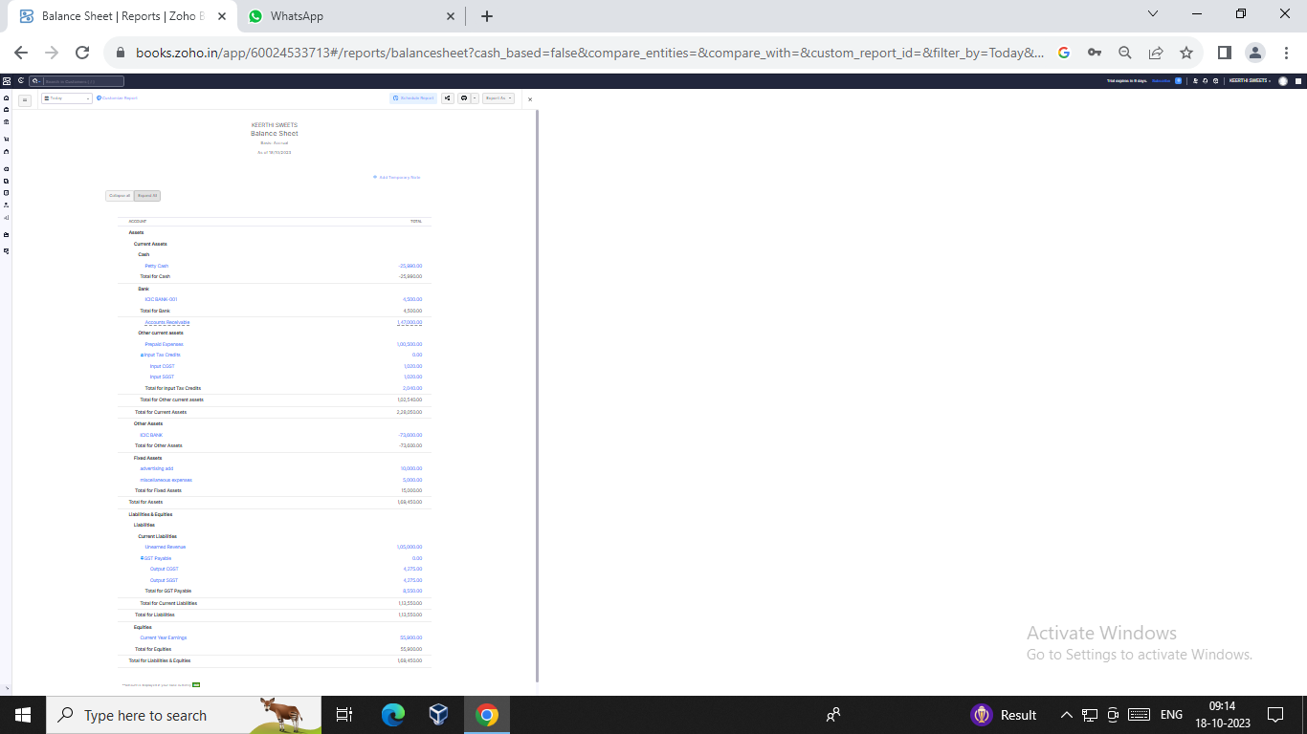

Purchase order:

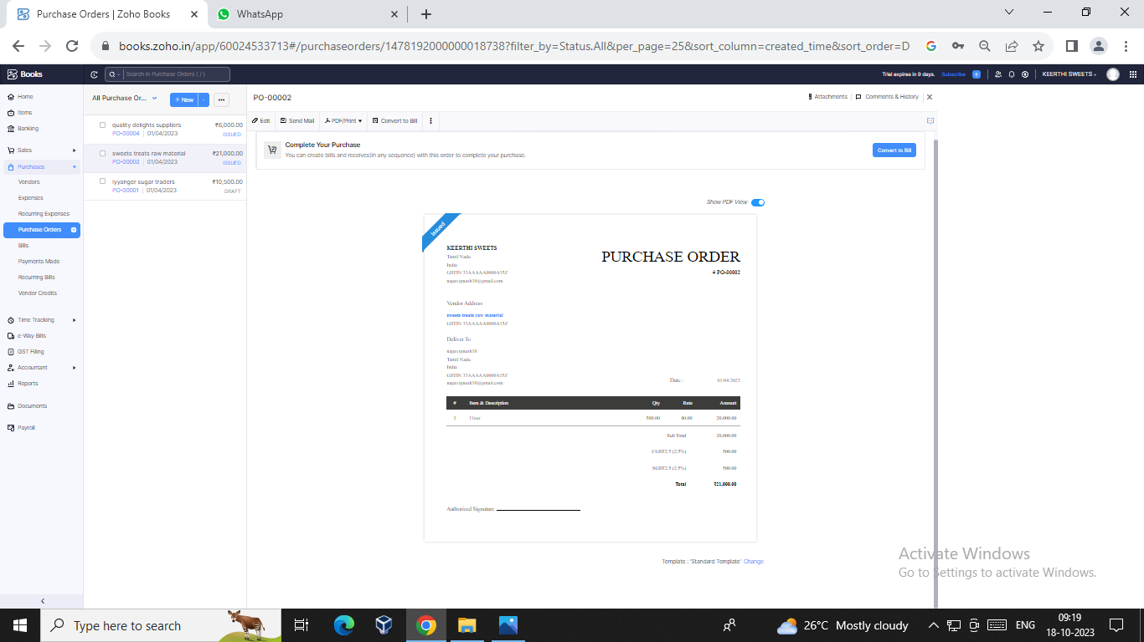

ADVANTAGES OF KEERTHI SWEETS:

In addition, sweets contain a few nutrients.

It is important to get carbohydrates, as they fuel our mood and body.

Aside from that, some sweets possess nutrients that can keep us healthy, such as vitamins, antioxidants, and fibers.

That is why eating sweets will not cause our bodies to suffer from a lack of nutrition.

DISADVANTAGES OF KEERTHI SWEETS:

From marinara sauce to peanut butter, added sugar can be found in even the most unexpected products.

Many people rely on quick, processed foods for meals and snacks. Since these products often contain added sugar, it makes up a large proportion of their daily calorie intake.

KEERTHI SWEETS.

**5.Conclusion:**

6.FUTURE SCOPE:

About Sugar ConfectionarySugar confectionery products have a high amount of sugar or sweetener. They aregenerally consumed as snack food.

1. **APPENDIX:**

<https://github.com/Nagavignesh001/https-github.com-Nagavignesh001-Keerthi-sweets_NM2023TMID23225/tree/main>

|  |
| --- |
|  |
| <!DOCTYPE html> |
|  | <html lang="en" data-color-mode="auto" data-light-theme="light" data-dark-theme="dark" data-a11y-animated-images="system" data-a11y-link-underlines="false"> |
|  |  |
|  | <style> |
|  | /* for each iteration, uncomment the CSS variable */ |
|  |  |
|  | /* light themes */ |
|  | [data-color-mode="light"][data-light-theme*="light"], |
|  | [data-color-mode="auto"][data-light-theme*="light"] { |
|  | /* iteration 1 */ |
|  | --border-color-iteration-1: #C8CCD0; |
|  | /* iteration 2 */ |
|  | --border-color-iteration-2: #BABFC5; |
|  | /* iteration 3 */ |
|  | --border-color-iteration-3: #A6ADB4; |
|  | /* iteration final */ |
|  | --border-color-iteration-4: #868F99; |
|  |  |
|  | /* the first value is the final step, which falls back to previous iterations */ |
|  | --control-borderColor-rest: var(--border-color-iteration-4, var(--border-color-iteration-3, var(--border-color-iteration-2, var(--border-color-iteration-1)))) !important; |
|  | } |
|  |  |
|  | /* dark themes */ |
|  | [data-color-mode="dark"][data-dark-theme*="dark"], |
|  | [data-color-mode="auto"][data-light-theme*="dark"] { |
|  | /* iteration 1 */ |
|  | --border-color-iteration-1: #363940; |
|  | /* iteration 2 */ |
|  | --border-color-iteration-2: #3F434B; |
|  | /* iteration 3 */ |
|  | --border-color-iteration-3: #4B5159; |
|  | /* iteration final */ |
|  | --border-color-iteration-4: #666E79; |
|  |  |
|  | /* the first value is the final step, which falls back to previous iterations */ |
|  | --control-borderColor-rest: var(--border-color-iteration-4, var(--border-color-iteration-3, var(--border-color-iteration-2, var(--border-color-iteration-1)))) !important; |
|  | } |
|  |  |
|  | [data-color-mode="dark"][data-dark-theme="dark_dimmed"], |
|  | [data-color-mode="dark"][data-dark-theme="light_high_contrast"], |
|  | [data-color-mode="dark"][data-dark-theme="dark_high_contrast"], |
|  | [data-color-mode="light"][data-light-theme="dark_dimmed"], |
|  | [data-color-mode="light"][data-light-theme="light_high_contrast"], |
|  | [data-color-mode="light"][data-light-theme="dark_high_contrast"] { |
|  | /* skip these themes, use the fallback */ |
|  | --control-borderColor-rest: initial !important; |
|  | } |
|  |  |
|  | @media (prefers-color-scheme: dark) { |
|  | /* dark colors in dark mode */ |
|  | [data-color-mode="auto"][data-dark-theme*="dark"] { |
|  | /* iteration 1 */ |
|  | --border-color-iteration-1: #363940; |
|  | /* iteration 2 */ |
|  | --border-color-iteration-2: #3F434B; |
|  | /* iteration 3 */ |
|  | --border-color-iteration-3: #4B5159; |
|  | /* iteration final */ |
|  | --border-color-iteration-4: #666E79; |
|  |  |
|  | /* the first value is the final step, which falls back to previous iterations */ |
|  | --control-borderColor-rest: var(--border-color-iteration-4, var(--border-color-iteration-3, var(--border-color-iteration-2, var(--border-color-iteration-1)))) !important; |
|  | } |
|  |  |

|  |
| --- |
|  |

·

-